Y Axis Frequency Increase Rate Limiter

Aim:

To stop slip of the motor the Y axis commands must be rate limited to stop jumps in commanded speed (or frequency)

Software Test:

Step input given to rate limiter, when output of rate limiter matches command, the timer is stopped.

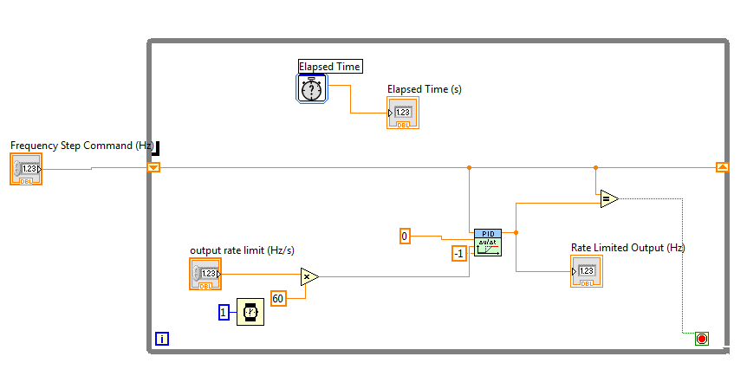

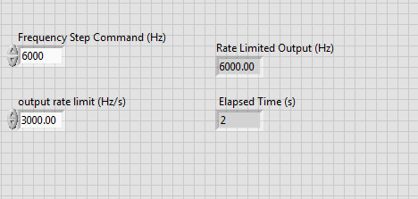

Results:

For an output rate limit of 3000Hz, the time taken to reach 6000Hz should be 2 seconds. This is demonstrated correctly.

Hardware Test:

Output Rate Limit (Hz/s) set to be 60,000 Hz/s as hardware characterisation test easily allowed an acceleration rate this high (max tested was 73,000Hz/s)

Step speed command given to Y axis speed controller, no slip observed

